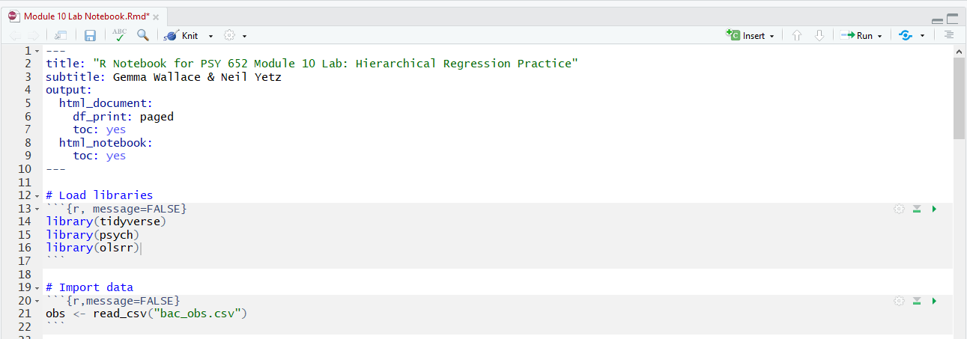

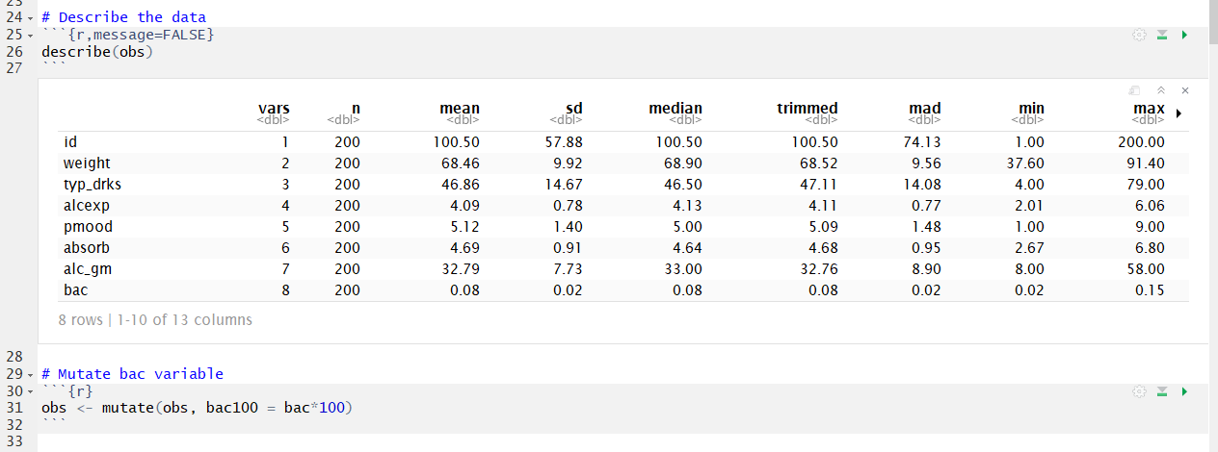

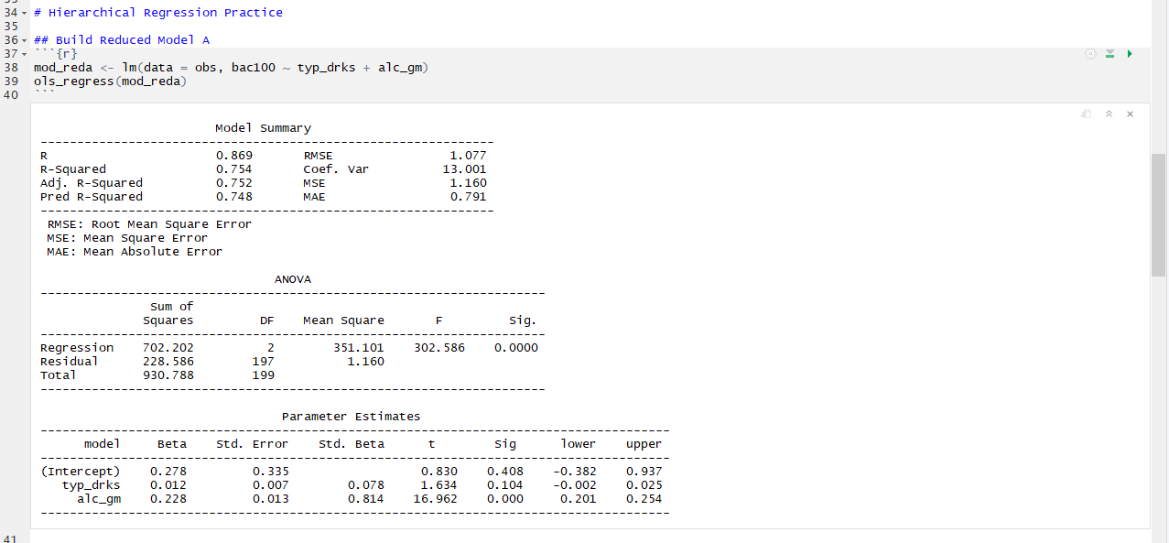

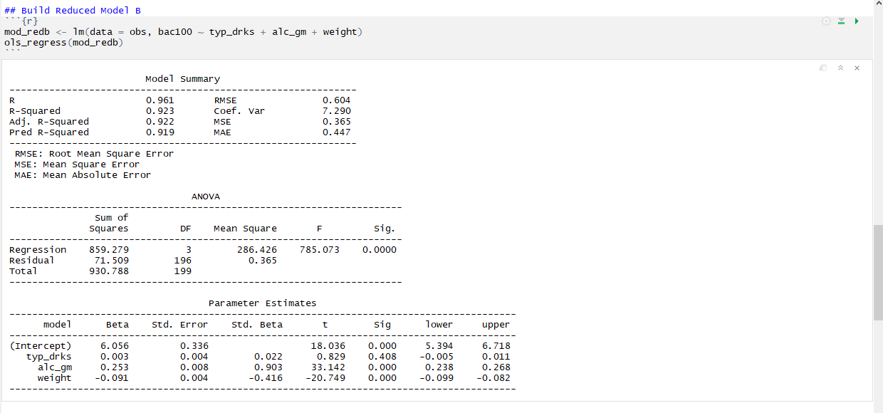

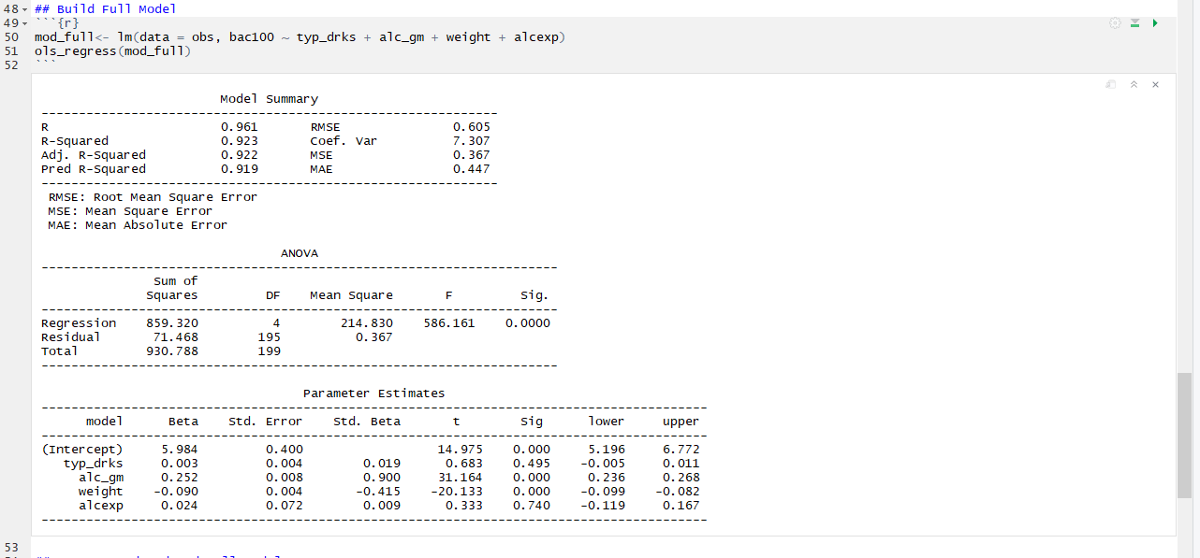

***In the white space below, calculate and interpret the unique variance in Y explained by each added predictor. (Hint: think of semi-partial correlation for your interpretations)***

Moving from Reduced Model A to Reduced model B increased the R2 value from .754 to .923. This means that weight adds 16.9% in explained variance in the outcome of BAC. Moving from Model B to Model C resulted in no change in the R2. This means that alcexp explains very little variance in BAC.

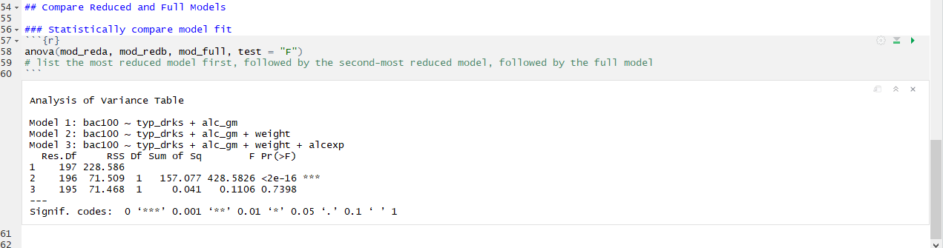

* + 1. ***In the white space below, interpret the partial F-test output and answer the following questions.***
       1. ***Does adding the weight variable result in a model that explains significantly more variance in bac100 than Reduced Model A (compare Reduced Model A and Reduced Model B)?***
          1. Yes, Model B explains a statistically significant amount more variance in BAC than model B.
       2. ***Does adding the alc_exp variable result in a model that explains significantly more variance in bac100 than Reduced Model B (compare Reduced Model B & Full Model)?***
          1. No, Model C does NOT explain any more variance in BAC than Model C.
       3. ***Reflect on your own research interests and write 2-3 sentences describing an example of when using hierarchical regression could be a good fit for your research. When might you actually use this?***
          1. Thanks for your answers. We enjoyed reading them 😊 – Neil & Gemma.